Monte Carlo Tree Search

Following are the steps that MCTS follows:

Steps:

1. Tree Traversal

UCB1 (Si) = Avg(Vi) + C x (sqrt( ln(N) / ni))

C = 2

1. Node Expansion
2. Rollout (Random Simulation)
3. Backpropagation

Algorithm

(For steps 1 and 2)

* currNode = S0
* If currNode == leafNode then
  + If ncurrNode == 0 then
    - Rollout
  + Else
    - For action in actions(currNode) add Results(currNode,action) to tree
    - currNode = first new node added to tree
    - Rollout

* Else
  + currNode = max(UCB1(for all childs of currNode))
  + Loop until you find a leafnode

Function Rollout(Si)

* While
  + If Si == Terminal
    - Return this state
  + actioni = random(Actions(Si))
  + Si = Results(Si , actioni)

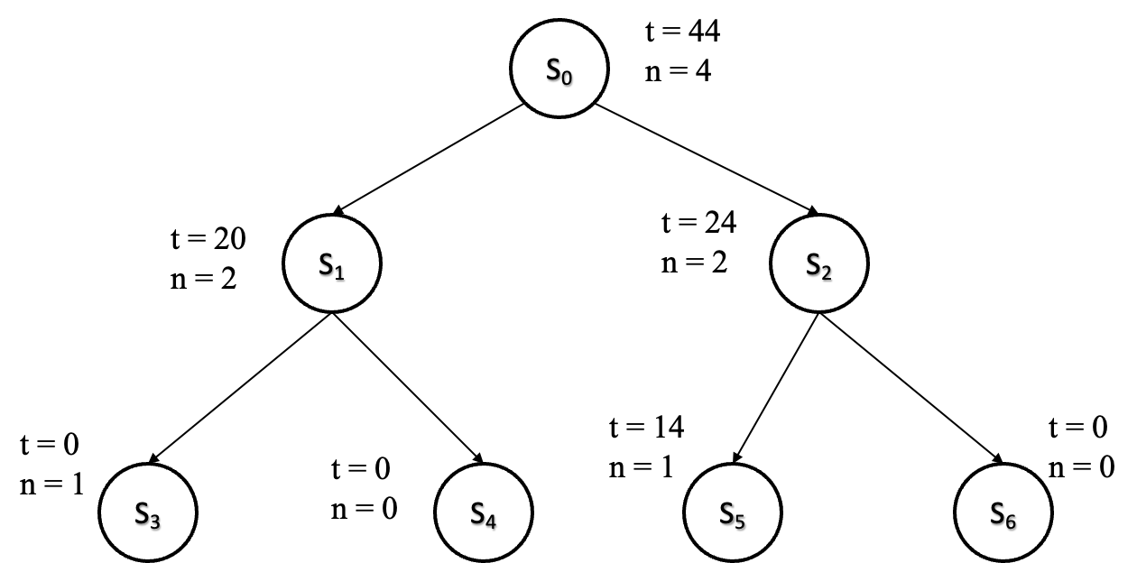

Consider the following tree. Let's say that we run another 4 iterations on the above tree using MCTS(Monte Carlo Tree Search) and the value ‘V’ after each iteration is [10, 15, 6, 0]. Draw the tree after every iteration and show the UCB1 value after each iteration.